**VERMICOMPOSTING**

|  |
| --- |
| DS18B20 Temperature Sensor |

**Components Required:**

* Arduino
* Breadboard
* Jumper wire
* 4.7k ohm resistor

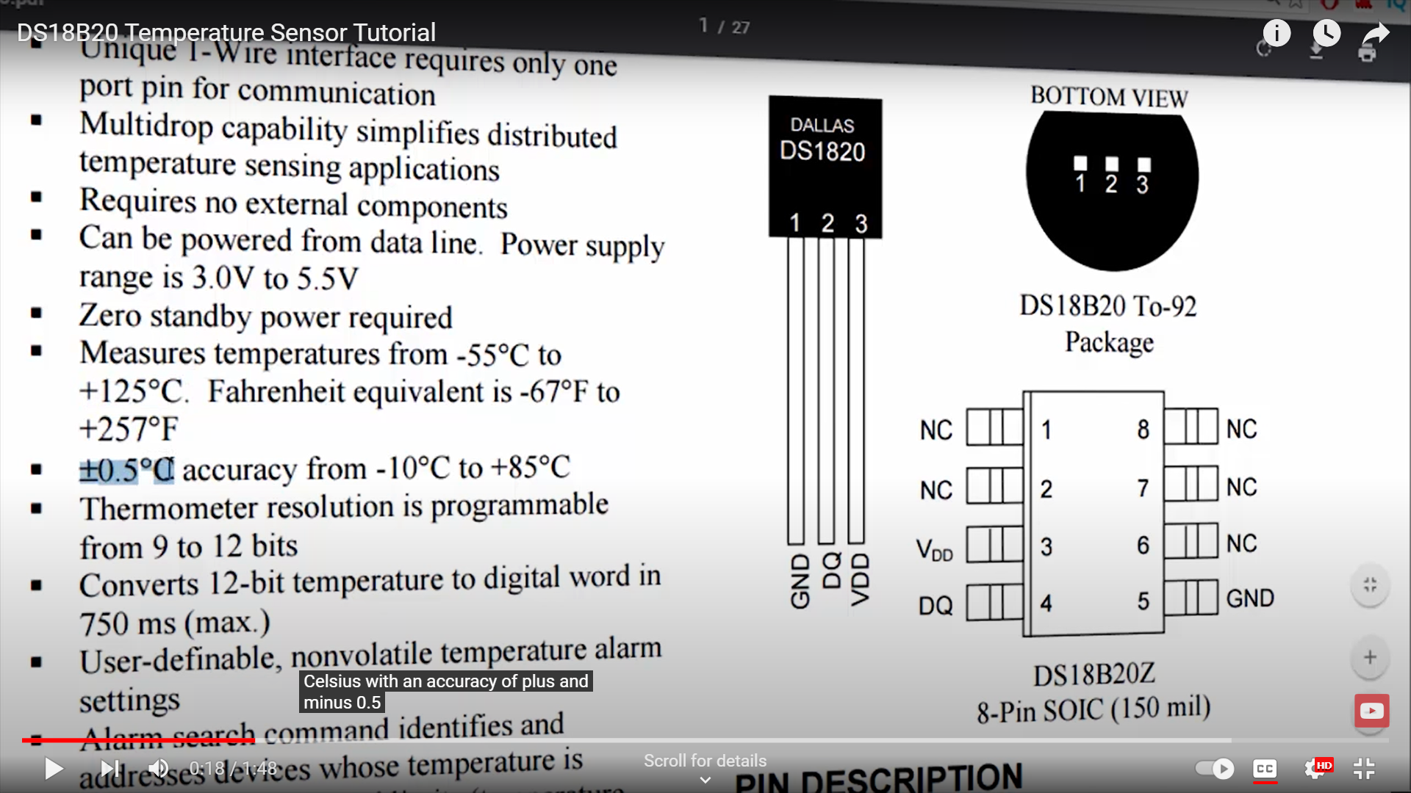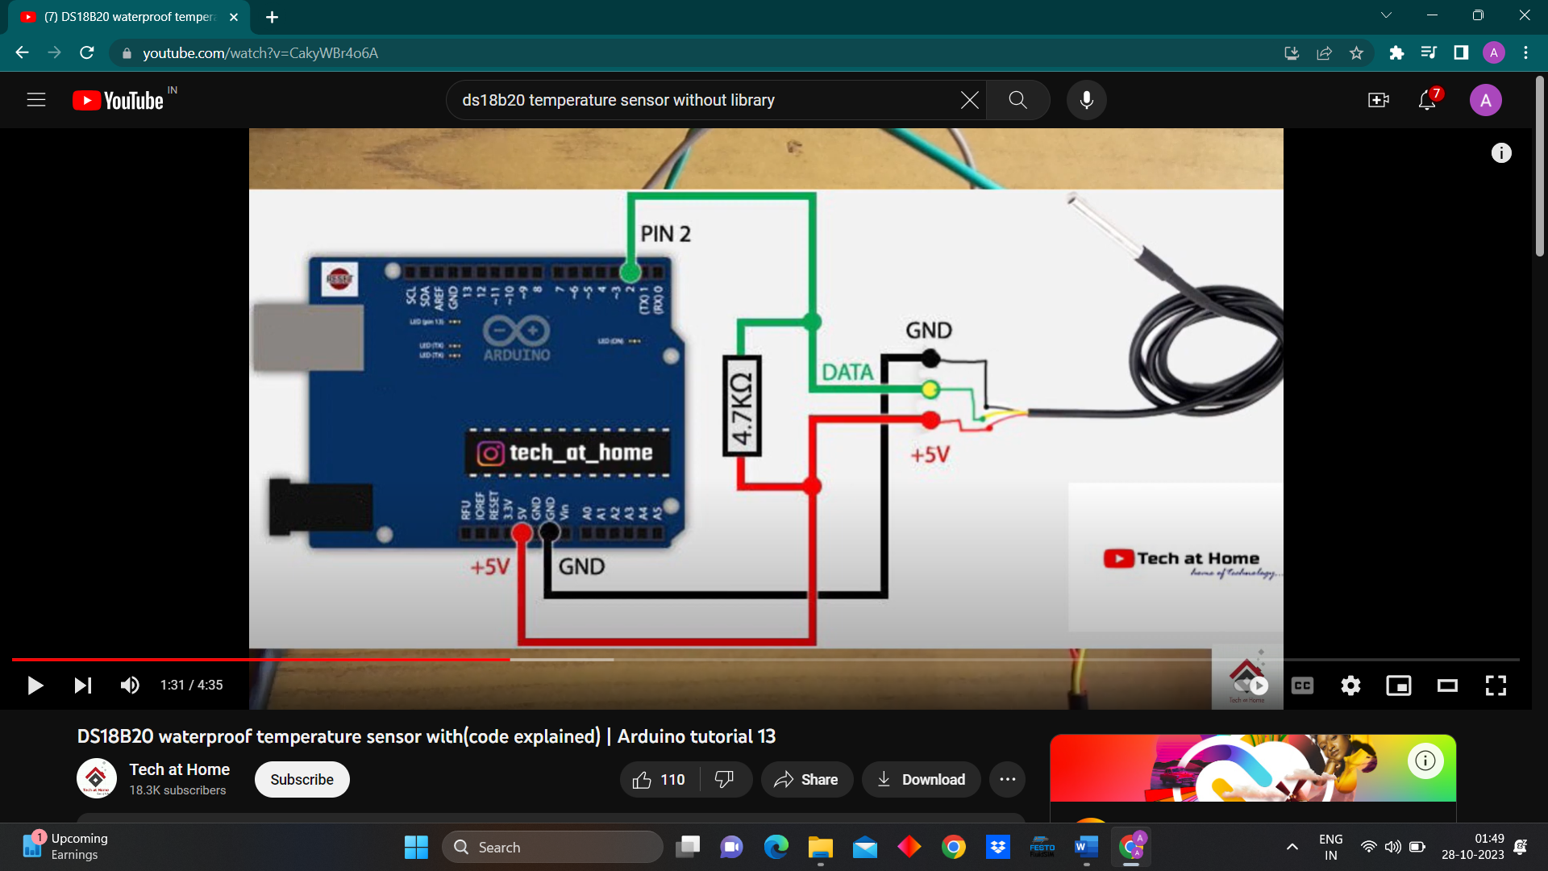

**Programming:**

We will include 2 pre defined libraries-

* onewire.h - This library simplifies the process of sending and receiving data over a single data wire, which is used for both power and communication in 1-wire devices.
* DallasTemperature.h - This library simplifies the process of sending and receiving data over a single data wire, which is used for both power and communication in 1-wire devices.

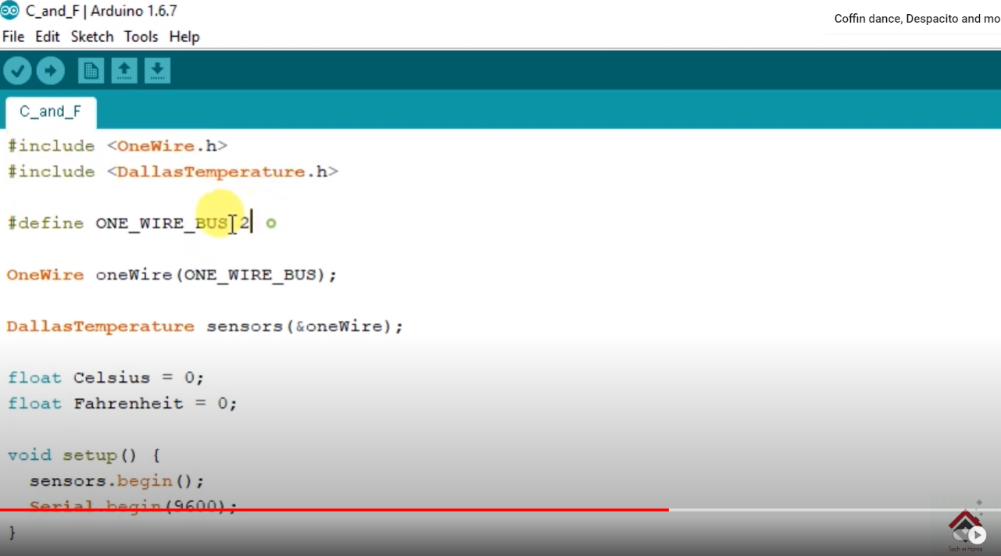

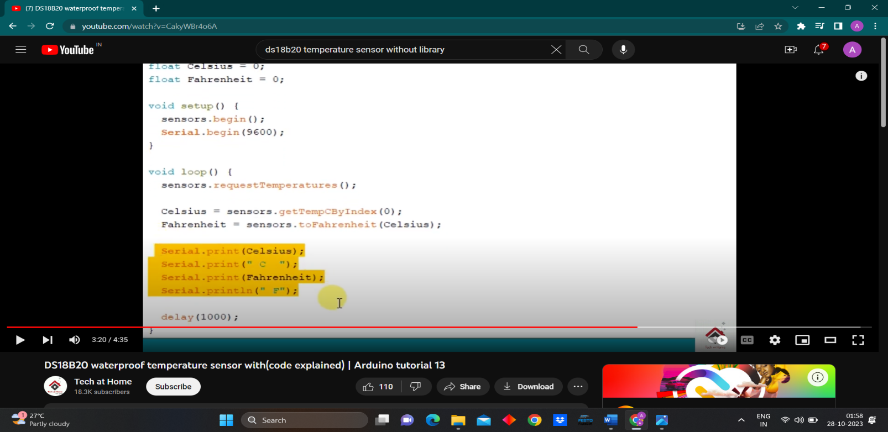

|  |
| --- |
| DFRobot Analog Waterproof Capacitive Soil Moisture Sensor |

**Components Required:**

* Arduino
* Breadboard
* Jumper wire

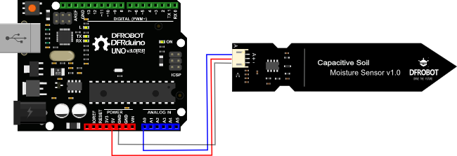

**Programming:**

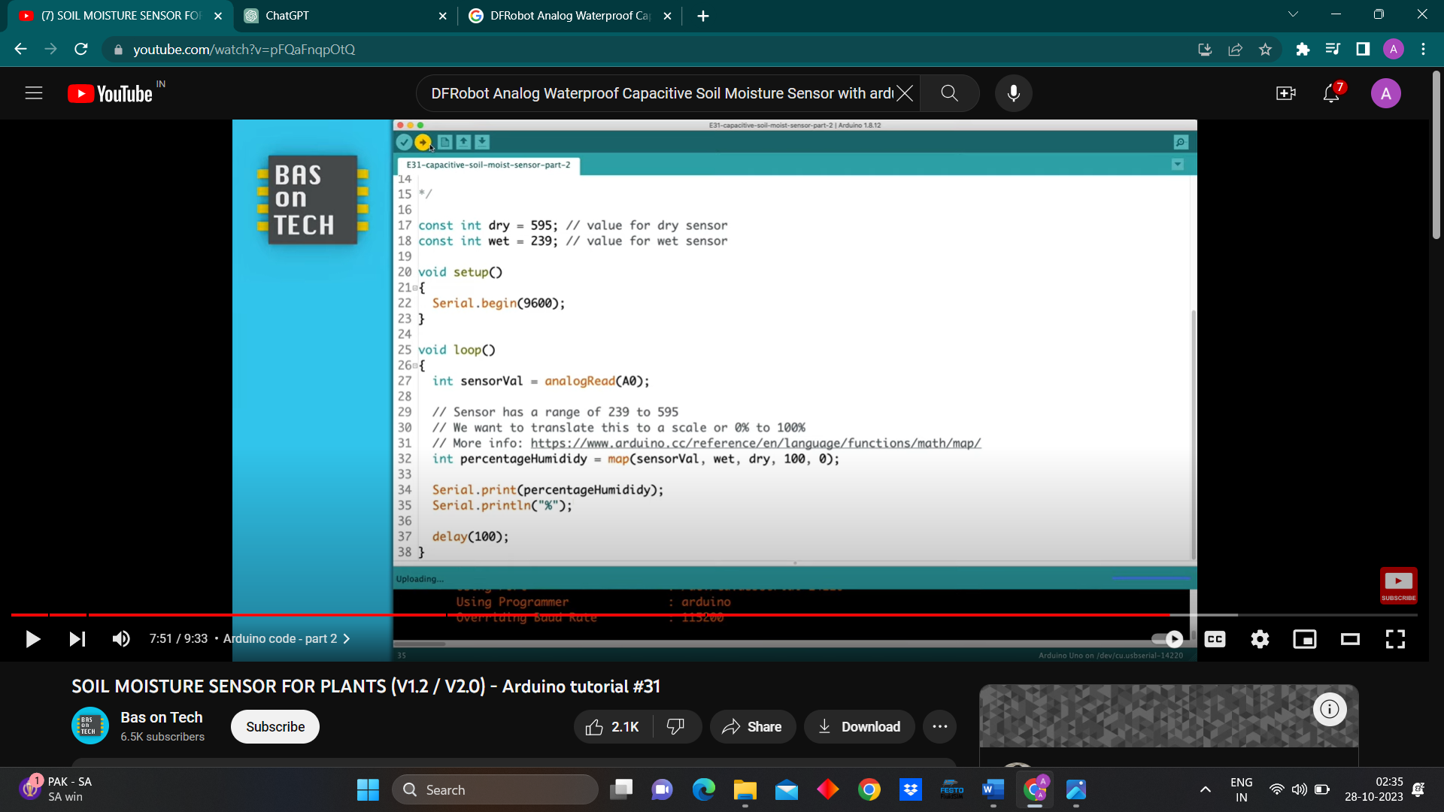

|  |
| --- |
| Analog pH Sensor |

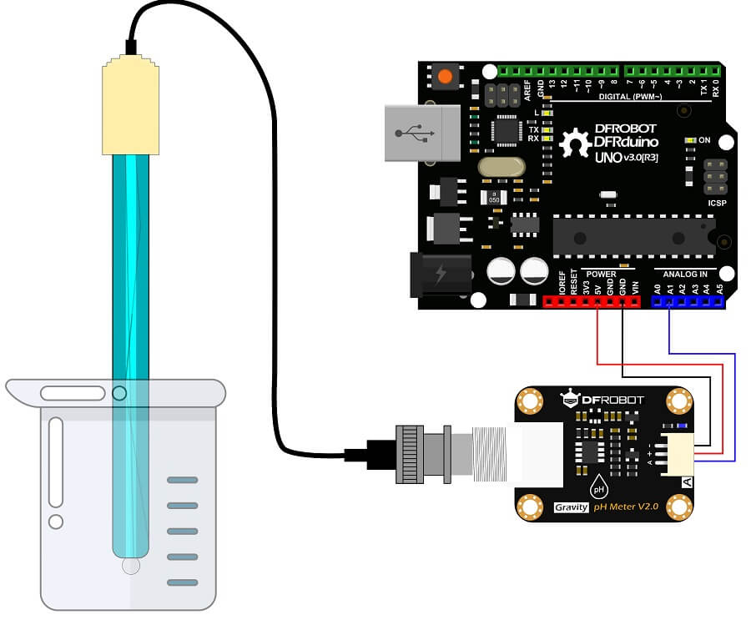

**Programming:**

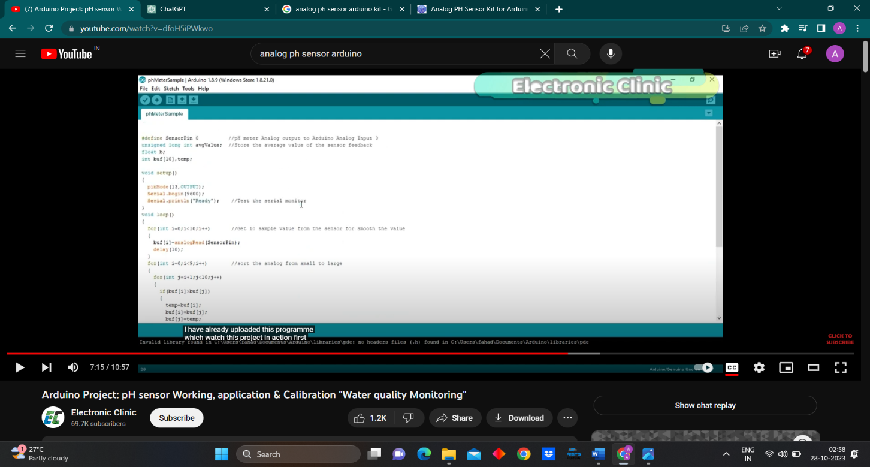

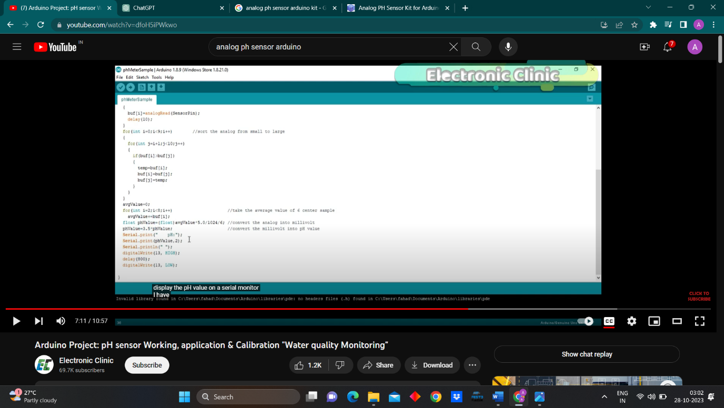

|  |
| --- |
| DFRobot Gravity: Analog Infrared CO2 sensor |

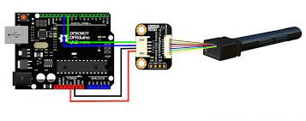

**Programming:**

|  |
| --- |
| Soil NPK sensor |

**Components Required:**

* rs485 modbus module